***A Mini Project Report on***

**Resume Builder**

**S.E. - I.T Engineering**

**Submitted By**

**Tanmay Poyekar (20104053)**

**Hitesh Sachdev (20104137)**

**Jai Rao (20104097)**

Under The Guidance Of

**Prof. Vishal Badgujar**



**DEPARTMENT OF INFORMATION TECHNOLOGY**

**A.P. SHAH INSTITUTE OF TECHNOLOGY**

G.B. Road, Kasarvadavali, Thane (W), Mumbai-400615

UNIVERSITY OF MUMBAI

**Academic year: 2021-22**

**CERTIFICATE**

This to certify that the Mini Project report on **Resume Builder** has been submitted by **Tanmay Poyekar (20104053), Hitesh Sachdev (20104137)** and **Jai Rao (20104097)** who are the students of A. P. Shah Institute of Technology, Thane, Mumbai, as a partial fulfilment of the requirement for the degree in Information Technology, during the academic year 2021-2022 in the satisfactory manner as per the curriculum laid down by University of Mumbai.

**Prof Vishal Badgujar**

**Guide**

**Prof. Kiran Deshpande Dr. Uttam D. Kolekar**  **Head of Department of Information Technology** **Principal**

**External Examiner(s):**

**Place:** A.P Shah Institute of Technology, Thane

**Date:**

**ACKNOWLEDGEMENT**

This project would not have come to fruition without the invaluable help of our guide **Prof.Vishal Badgujar** sir. Expressing gratitude towards our HoD, **Prof. Kiran Deshpande**, and the Department of Information Technology for providing us with the opportunity as well as the support required to pursue this project. We would also like to thank our teacher **Ms. Vidya Seth** who gave us her valuable suggestions and ideas when we were in need of them. We would also like to thank our peers for their helpful suggestions.

**TABLE OF CONTENTS**

1. Introduction...........................................................................5

1.1 Purpose......................................................................................6

1.2 Objectives...................................................................................6

1.3 Scope.........................................................................................6

1. Problem Definition...............................................................................................7
2. Proposed System................................................................................................ 7
   1. Features and Functionality ................................................................................. 8
3. Project Outcomes................................................................................................ 8

5. Software Requirements....................................................................................... 9

6. Project Design..................................................................................................... 10

6.1 Implementation………………………………………………………………… 12

7. Database Design………………………………………………………………. 18

7.1 ER Model………………………………………………………………………19

8. Project Scheduling .......................................................................................................... 20

9. Conclusion. ..................................................................................................................... 21

10. Reference………………………………....................................21

**Chapter 1**

**Introduction**

A resume is a formal document that serves to show a person’s career background and skills. In most cases, it’s created in order to help a candidate to land a new job.

A [traditional resume](https://zety.com/blog/traditional-resume) consists of a professional summary, work history, and education sections.

It works like your job hunt marketing document.

A resume builder is an application developed to simplify the task of creating a resume for individuals.

A resume builder is a software developed to simplify the task of creating a resume for individuals. The application provides an effective means of designing desired resume in fact a professional looking resume. The system is flexible to be used and reduces the need of thinking and designing an appropriate resume. Hence the system is developed to provide them an easy way for creating a professional looking resume.

Individuals just have to fill up a form that specifies questions from all required fields such as personal questions, educational, qualities, interest, skills and so on. The answers provided by the users are stored and the system generates a well structured resume.

Online resumes are the new way to apply for employment.

The application reduces errors while entering the data. It also provides error message while entering invalid data. No formal knowledge is needed for the user use this system.

**1.1Purpose**

The purpose of a resume is tointroduce yourself to employers, present your qualifications, and secure an interview.

The goal of writing a resume is to showcase your experience, education, and skills in a standardized format which is easy for recruiters to read.

Because of this computerization process, manual work has been eliminated and manual errors can be overcome easily.

**1.2 Objectives:**

* To detail your skills and training, work experience, education, and most importantly, the accomplishments you have made with past employers.
* To create resume online which maintains proper records of user’s personal information, skills, qualification details, work experience
* To give flexibility to users to design resume according to their requirement.
* To provide an easy way for creating a professional looking resume.
  1. **Scope:**
* So our application is user friendly and easy to use.
* The individual just have to fill up a form regarding his/her personal, Qualification details, his/her Work experiences, Skills and so on.
* The main advantage of online resumes is that they are instant.
* The application provides an effective means of designing a resume.

**Chapter 2**

**Problem Definition:**

* Making resume manually consume more time.
* Usually individuals get confused while creating a resume especially graduate students. They don’t get a clear idea of what things and information must be included in a resume.
* There is no database to store and retrieve the data from MS-Word.
* Some resume builders are purely online and don’t have the functionality to allow the user to save their resume to other word processing software such as Microsoft Word, and often you can only print out what you have completed online. Some of the resume builders only provide you with a PDF copy of your resume which again restricts you for further adaption or updating.

**Chapter 3**

**Proposed System**

The individual just have to fill up a form regarding his/her personal, Qualification details, his/her Work experiences, Skills and so on.

Our system will store the entered data and generates a well structured resume.

Because of this computerization process, manual work has been eliminated and manual errors can be overcome easily

**3.1 Features and Functionality:**

1. User login
   * User have to create an account by registering themselves. Then they can login and can utilize the services.
2. Resume form
   * User will be given a form to be filled. The form includes Personal details, Skills, Hobbies, Experience, Interest, and Qualification details.
3. Convert to Pdf
   * User can even download his/her resume in pdf format.
   * Users have option to create resume in pdf format.

**Chapter 4**

**Project Outcomes:**

* User Can login & Signup.
* User can create resume by filling up the details like:  
  1.Personal details

2.Qualification details

3.Skills

4.Work experience

* User can update his/her details.
* User can even Download his/her resume.
* User will be able to make resume by selecting whether the user is fresher or experienced.

**Chapter 5**

**Software Stack:**

* **Development Eclipse IDE**  **2021-09 (4.21.0)**

Eclipse is an integrated development environment (IDE) used in computer programming.

It contains a base workspace and an extensible plug-in system for customizing the

environment. Eclipse is written mostly in Java and its primary use is for developing Java

applications. Eclipse software development kit (SDK) is free and open-source software,

released under the terms of the Eclipse Public License, although it is incompatible with

the GNU General Public License.

* **Frontend: JAVAFX**

JavaFX is a software platform for creating and delivering desktop applications, as well as rich web applications that can run across a wide variety of devices.

JavaFX is a set of graphics and media packages that enables developers to design, create, test, debug, and deploy rich client applications that operate consistently across diverse platforms. JavaFX is a Java library that consists of classes and interfaces that are written in native Java code.

* **Backend: MySQL**

MySQL is an open-source relational database management system (RDBMS). SQL stands for Structured Query Language. SQL is a language programmers use to create, modify and extract data from the relational database, as well as control user access to the database. MySQL is pretty easy to master in comparison with other database software like Oracle Database, or Microsoft SQL Server. MySQL can run on various platforms UNIX, Linux, Windows, etc. You can install it on a server or even in a desktop. Besides, MySQL is reliable, scalable, and fast.

**Chapter 6**

**Project Design:**

In this phase, a logical system is built which fulfils the given requirements. Design phase of software development deals with transforming the client’s requirements into a logically working system. Normally, design is performed in the following in the following two steps:

1. Primary Design Phase: In this phase, the system is designed at block level. The blocks are created on the basis of analysis done in the problem identification phase. Different blocks are created for different functions emphasis is put on minimizing the information flow between blocks. Thus, all activities which require more interaction are kept in one block.

2. Secondary Design Phase: In the secondary phase the detailed design of every block is performed.

The general tasks involved in the design process are the following:

1. Design various blocks for overall system processes.

2. Design smaller, compact and workable modules in each block.

3. Design various database structures.

4. Specify details of programs to achieve desired functionality.

5. Design the form of inputs, and outputs of the system.

6. Perform documentation of the design.

User Interface Design: User Interface Design is concerned with the dialogue between a user and the computer. It is concerned with everything from starting the system or logging into the system to the eventually presentation of desired inputs and outputs. The overall flow of screens and messages is called a dialogue.

The following steps are various guidelines for User Interface Design:

1. The system user should always be aware of what to do next.

2. The screen should be formatted so that various types of information, instructions and messages always appear in the same general display area.

3. Message, instructions or information should be displayed long enough to allow the system user to read them.

4. Use display attributes sparingly.

5. Default values for fields and answers to be entered by the user should be specified.

6. A user should not be allowed to proceed without correcting an error.

7. The system user should never get an operating system message or fatal error.

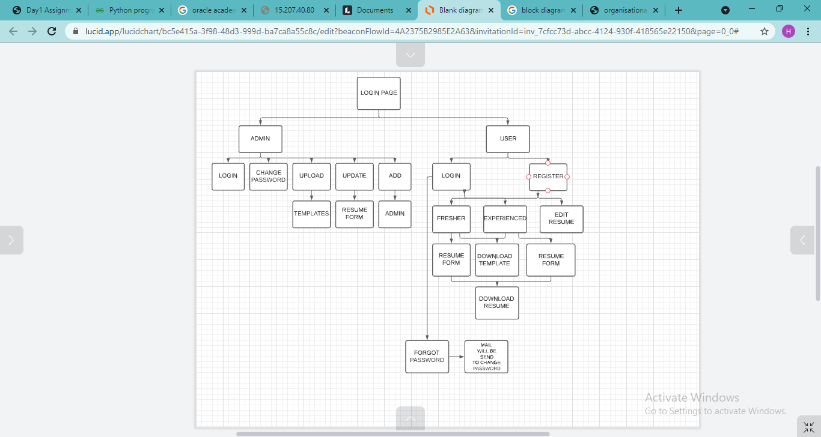

Figure 6.1: Block Diagram

**6.1 Implementation:**

* Home Page

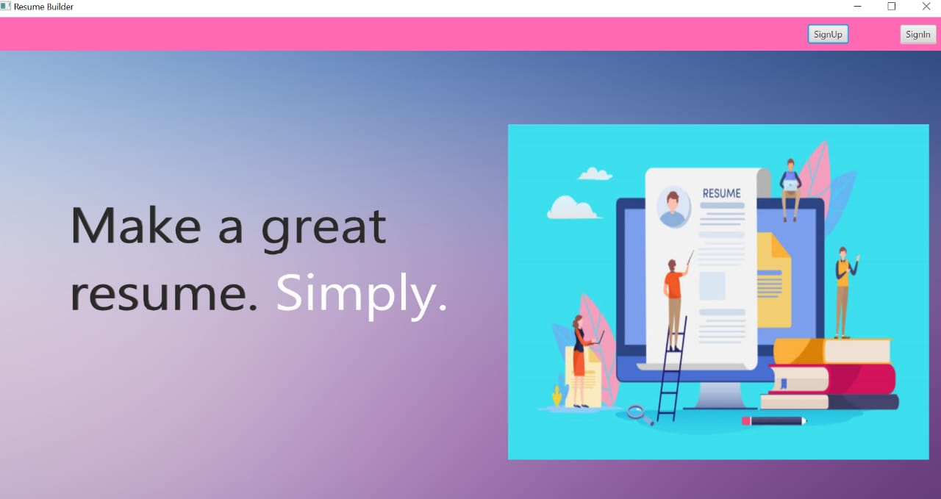

User can sign into his/her account, and new user can sign up for new account.

* Login Page:

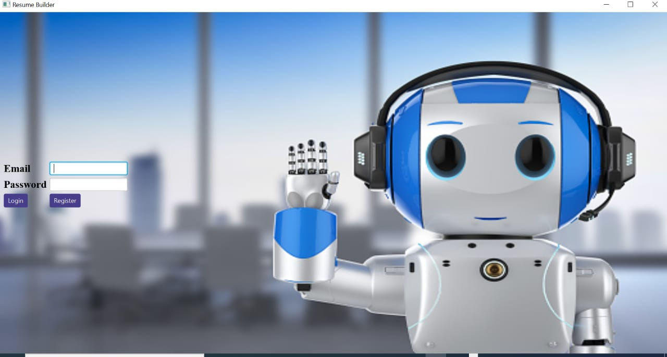

User can login in his/her account by entering valid Email and Password.

New user should click on register button for creating new account.

* Registration Page:

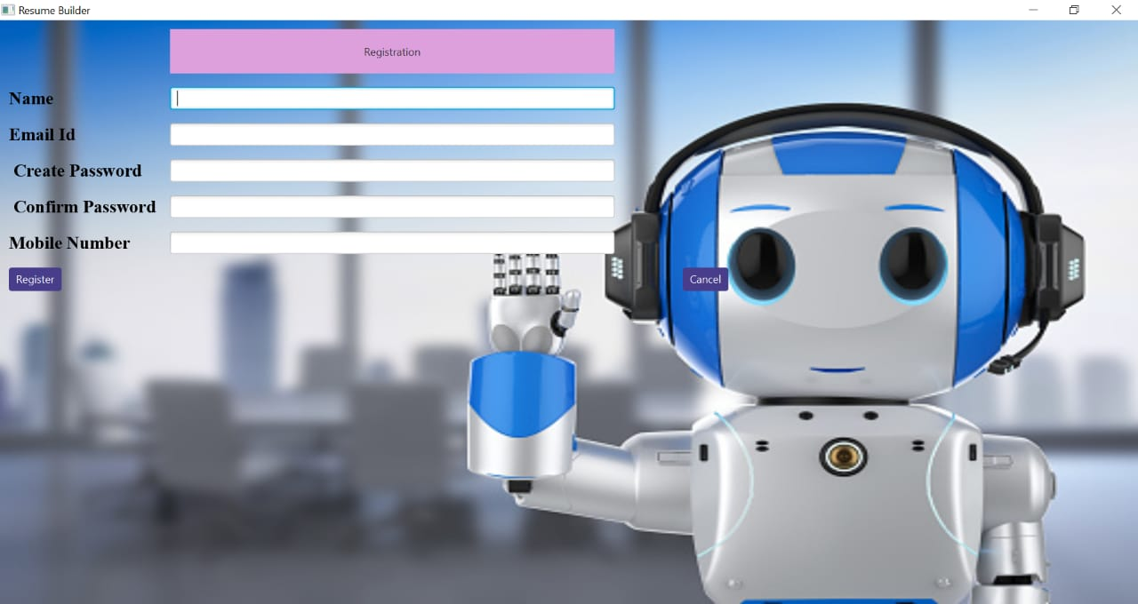

For creating a new account user should enter his/her Name, Email Id, Contact Number and should create new password. User have to confirm password after creating.

* Dashboard:

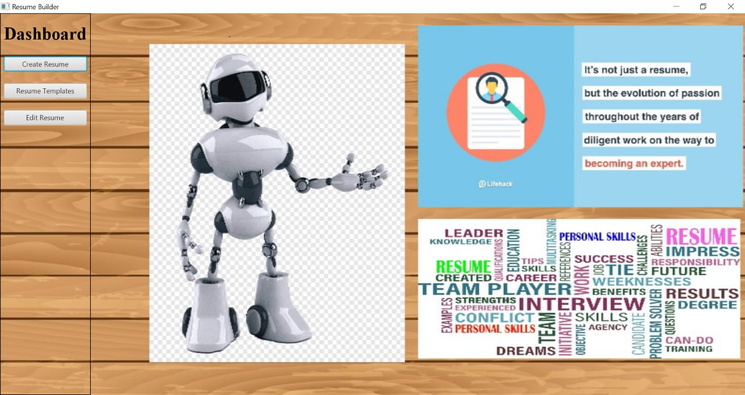

After login user can start creating the resume by clicking on Create Resume button.

User can also edit his/her resume anytime on page.

* Personal Details:

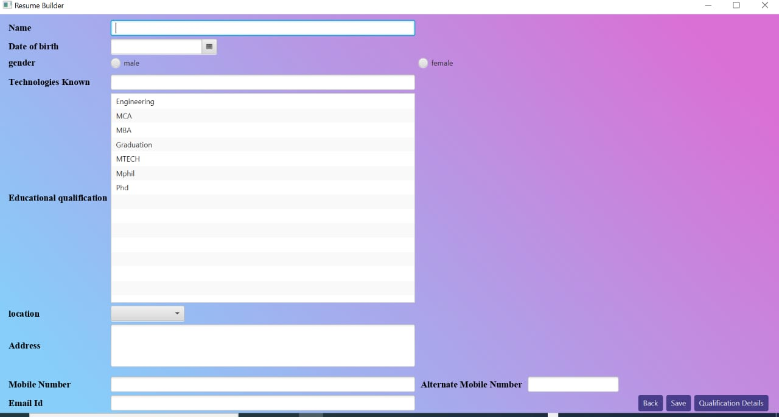You should start creating your resume by filling your personal details on this page.

* Qualification Page:

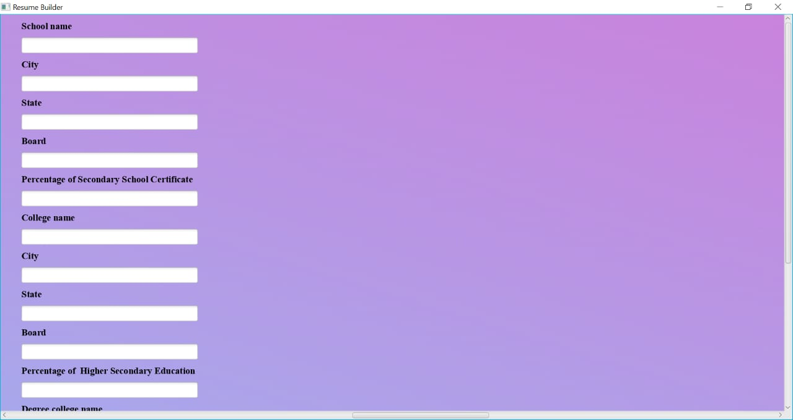

On this page user should fill his/her qualification details in resume.

* Work Experience Page:

User should add his/her work experience on this page, if user is not experienced, user should click on Fresher button

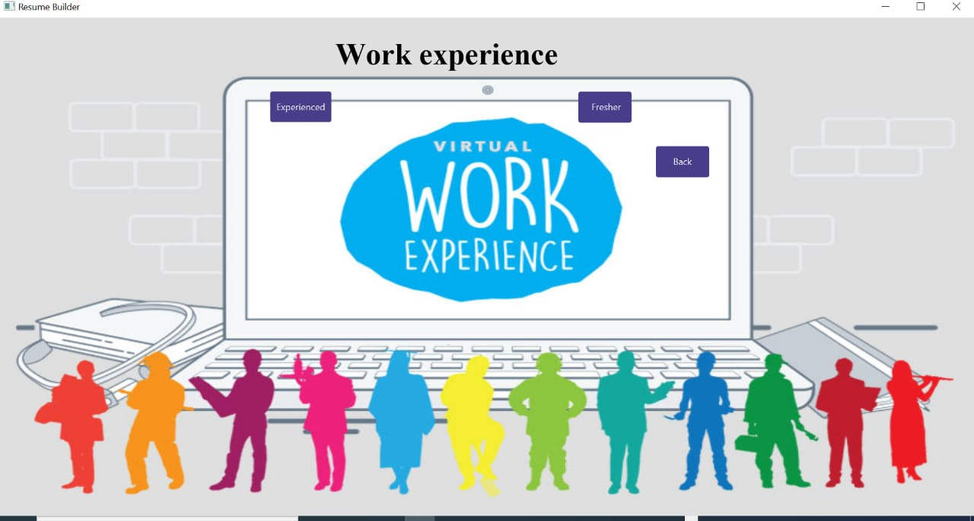

* Experience Page:

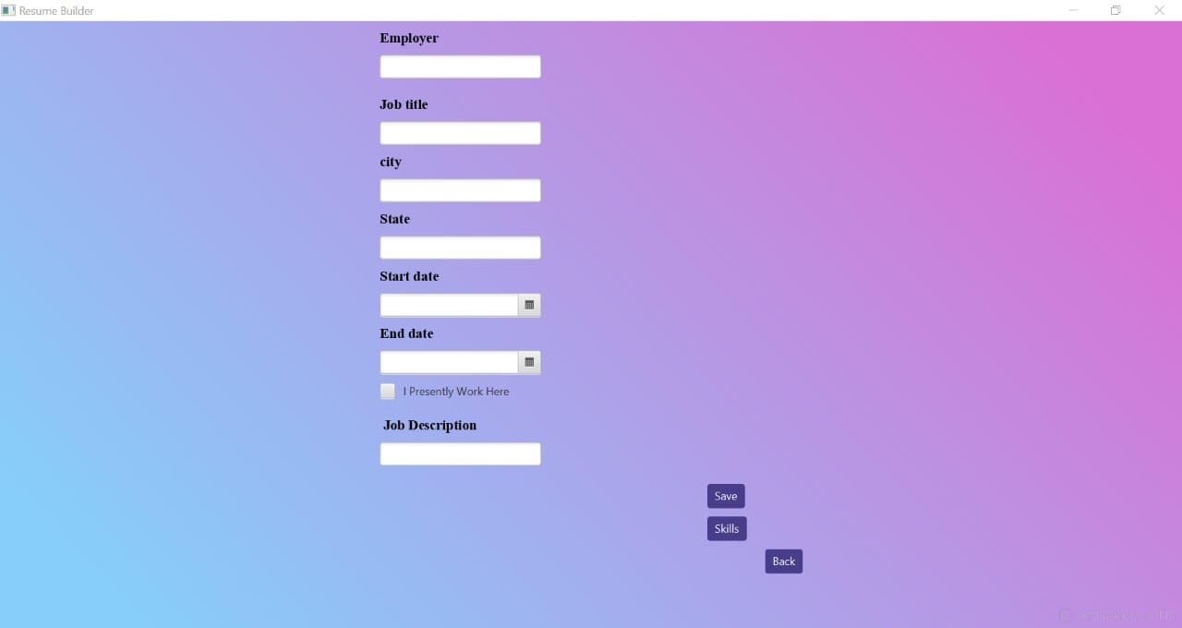

Experienced user can start filling this page.

* Fresher’s Page:

On this page freshers should fill this form.

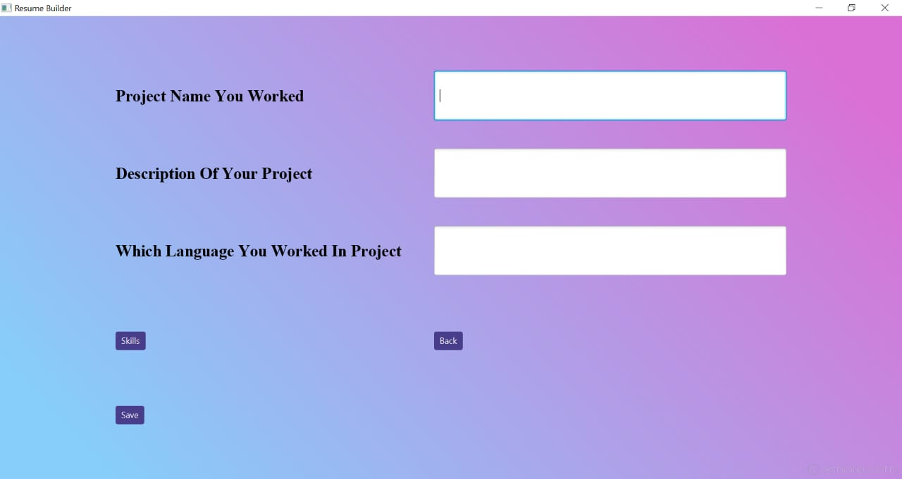

* Skills Page:

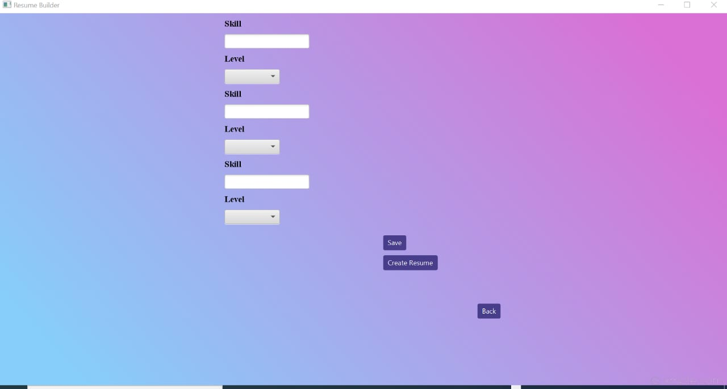

User should enter his/her skills on this page by selecting from dropdown box given.

By clicking on create resume button user can download his/her resume.

**Chapter 7**

**Database Design**

**7.1 ER Model**

ER model stands for an Entity-Relationship model. It is a high-level data model. This model is used to define the data elements and relationship for a specified system.

It develops a conceptual design for the database. It also develops a very simple and easy to design view of data.

In ER modeling, the database structure is portrayed as a diagram called an entity-relationship diagram. Below diagram represent the ER model of Resume Builder. ER model starts with the User which is a Strong Entity and has Email and a password as an attributes. Further the user will create or manages Resume which is a strong entity and has three entity i.e. personal details, skills, qualification. personal details have name, address, DOB, Email and phone no is a multivalued attribute. skills have two attributes i.e. skill type, skill level. Qualification Entity include school name, college name, city, state, percentage. Now the Resume entity has experienced and freshers as a two attributes. Freshers entity include description, language, Project name as an attributes and Experienced Entity include two attributes i.e. Job title and job description.

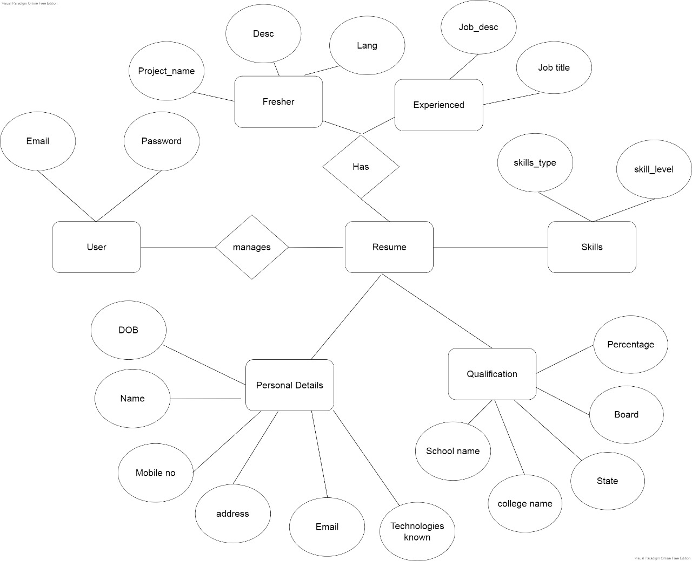

**Figure 7.1: ER model**

**Chapter 8**

**Project Scheduling Template**

|  |  |  |  |
| --- | --- | --- | --- |
| **Sr. No** | **Group Member** | **Time duration** | **Work to be done** |
| **1** | Tanmay Poyekar  Jai Rao  Hitesh Sachdev | 1st week of January | Implementing GUI for Registration page and Login page |
| 2nd week of January | Testing GUI with data base with Registration Page and Login Page |
| **2** | Tanmay Poyekar  Jai Rao  Hitesh Sachdev | 3rd week of January | Implementing GUI frames and connecting each other |
| **3** | Hitesh Sachdev  Jai Rao  Tanmay Poyekar | By the end of march month | GUI with database connectivity |

**Chapter 9**

**Conclusion**

The online resume builder is one of the best systems for the people who are either fresher's in their domain or if they don’t have enough idea about the resume or don’t have enough time to create the resume of good designs or patterns then this platform is very productive place for them. It saves a lot of time and cost effective.

**9.1 References:**

<https://docs.oracle.com/javase/8/scene-builder-2/get-started-tutorial/jfxsb-get_started.htm>

<https://docs.oracle.com/javafx/2/get_started/form.htm>

To open new window in javafx:

https://www.quickprogrammingtips.com/java/how-to-open-a-new-window-in-javafx.html